Deep features for image retrieval

7 questions

1.

What’s the least common category in the training data?



**bird**



**dog**



**cat**



**automobile**

2.

What is the nearest ‘cat’ labeled image in the training data to the the first image in the test data (image_test[0:1])?



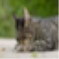



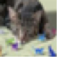



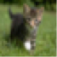



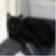



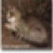



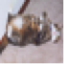

3.

What is the nearest ‘dog’ labeled image in the training data to the the first image in the test data (image_test[0:1])?



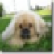



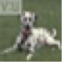



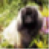



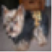



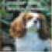



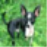

4.

For the first image in the test data, in what range is the mean distance between this image and its 5 nearest neighbors that were labeled***‘cat’*** in the training data?



**33 to 35**



**35 to 37**



**37 to 39**



**39 to 41**



**Above 41**

5.

For the first image in the test data, in what range is the mean distance between this image and its 5 nearest neighbors that were labeled***‘dog’***in the training data?



**33 to 35**



**35 to 37**



**37 to 39**



**39 to 41**



**Above 41**

6.

On average, is the first image in the test data closer to its 5 nearest neighbors in the ***‘cat’*** data or in the ***‘dog’***data?



**cat**



**dog**

7.

In what range is the accuracy of the 1-nearest neighbor classifier at classifying ‘dog’ images from the test set?



**50 to 60**



**60 to 70**



**70 to 80**



**80 to 90**



**90 to 100**